Ulric Aird

**Networking 2**

Practice Exam: VLAN and Inter-VLAN Communication

For this practical exam, I have managed to create an Inter-VLAN communication between each device.

These screenshots shows the proper vlans on the PCs for different devices. All PCs has proper IP Configurations with default gateway for their specific vlan.

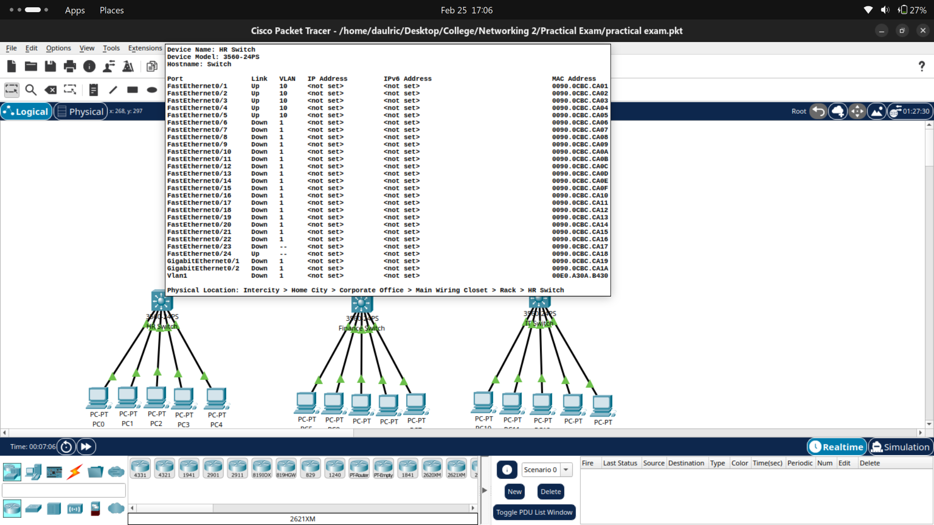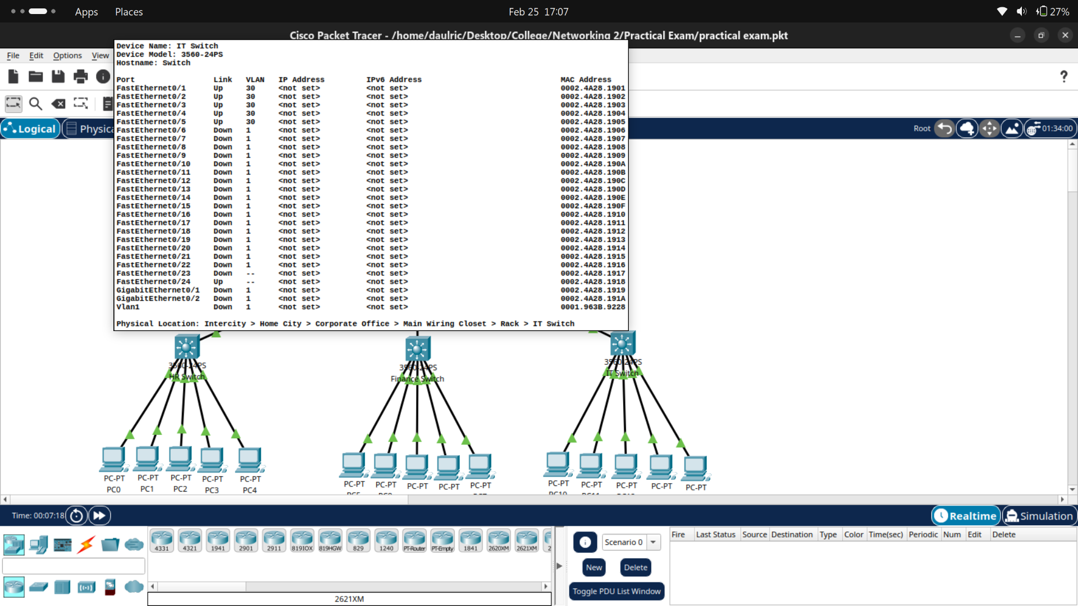

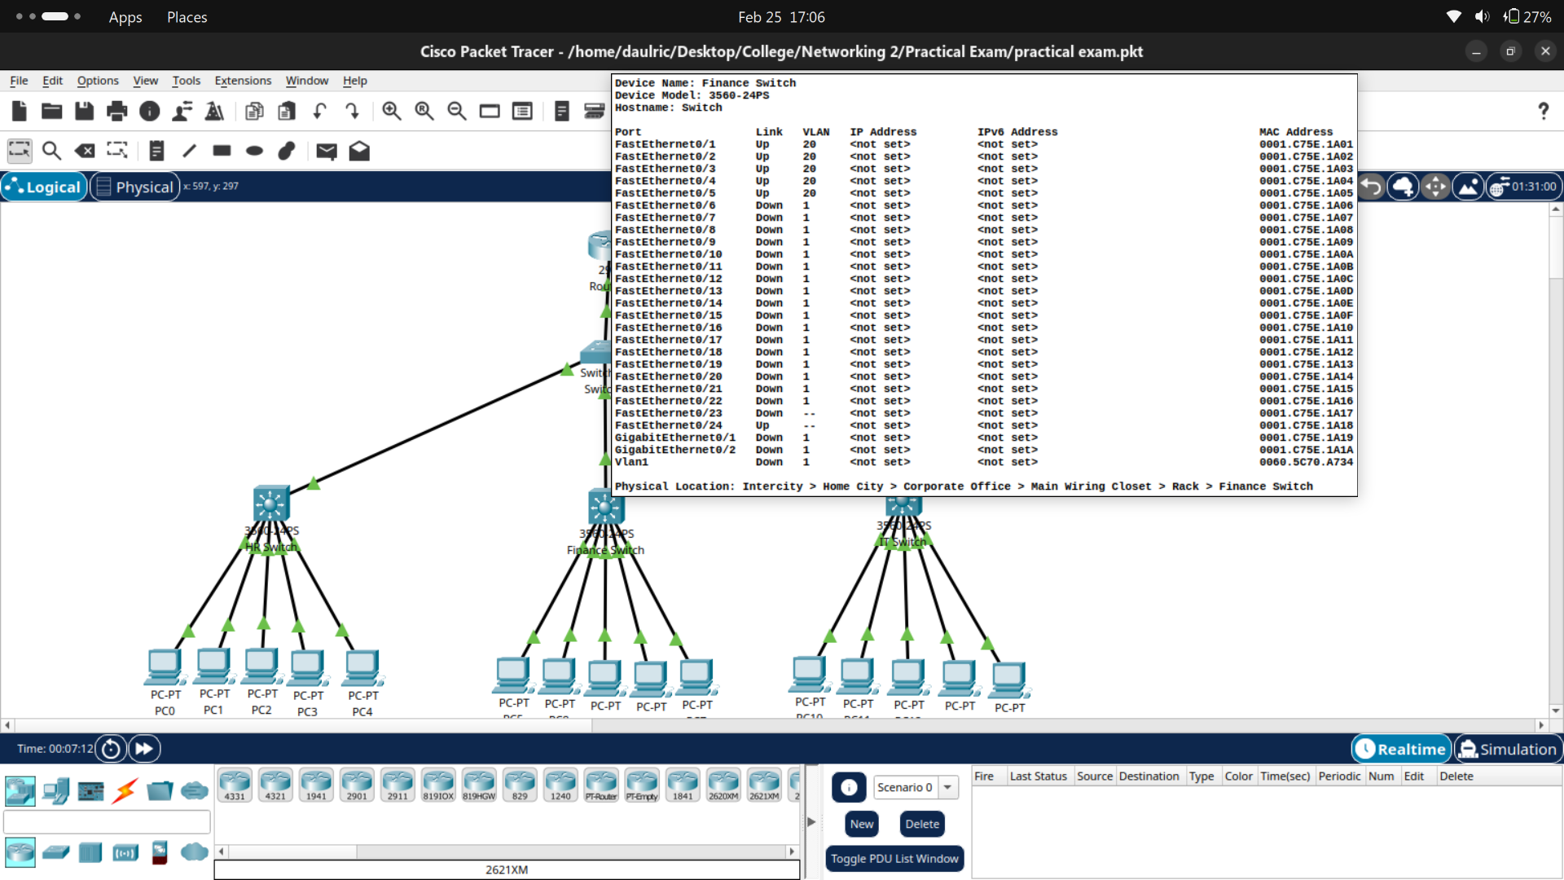

These are the vlans for each switches. A switch was created for the sole purpose of connecting the Router and the Multi-Layer switch together. The switch has trunking enable for all connected ports.

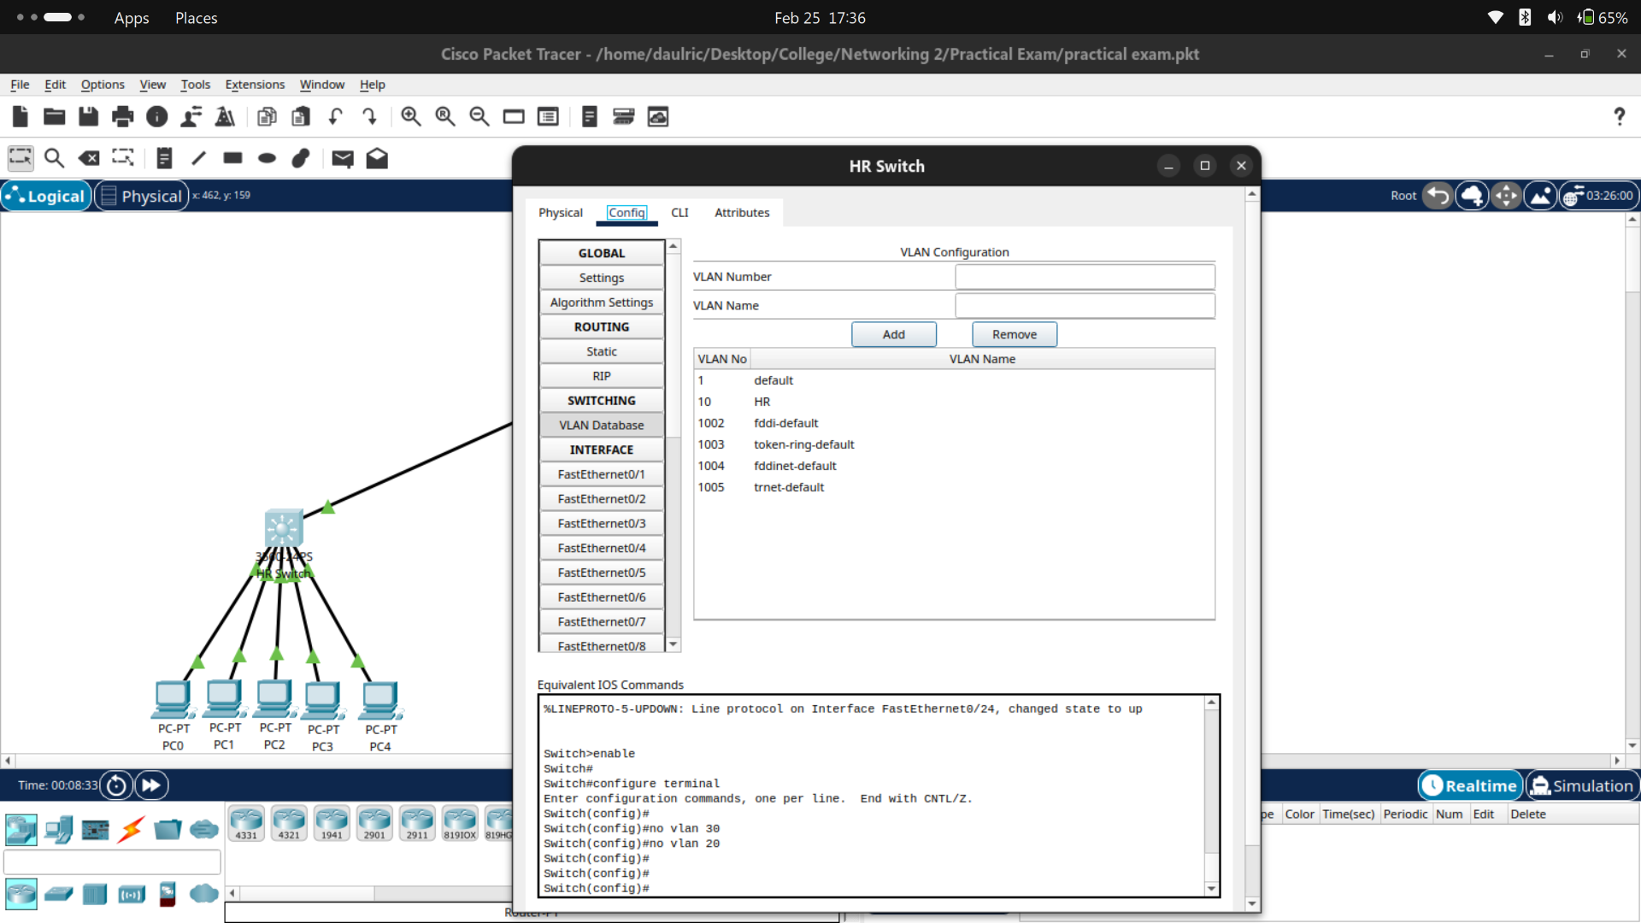

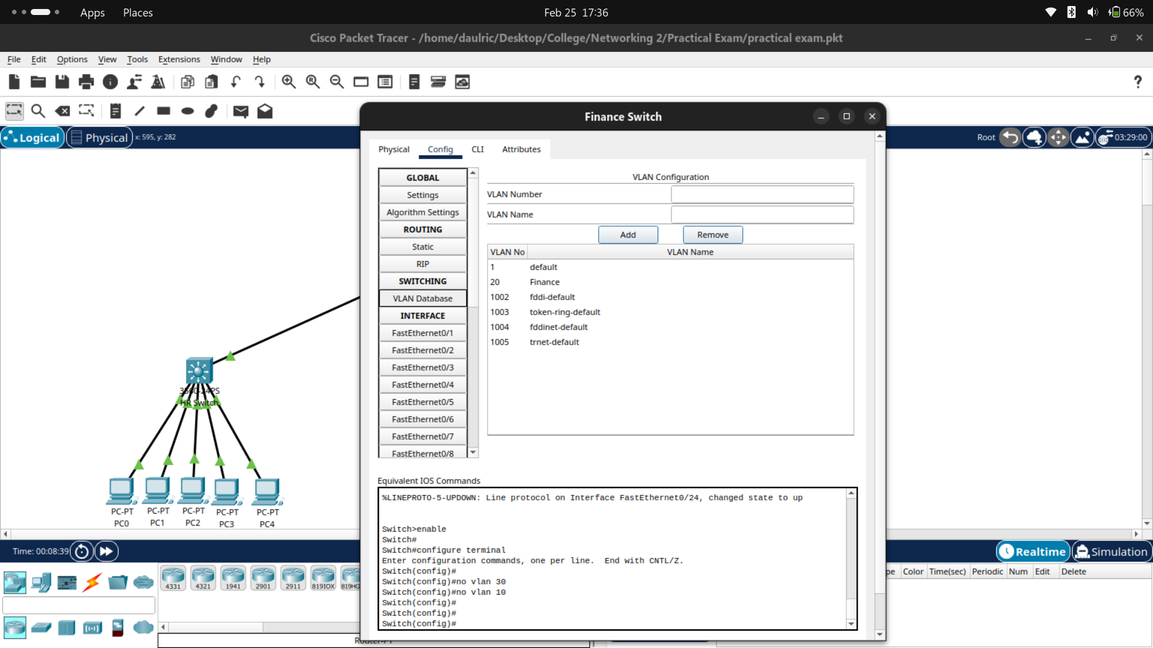

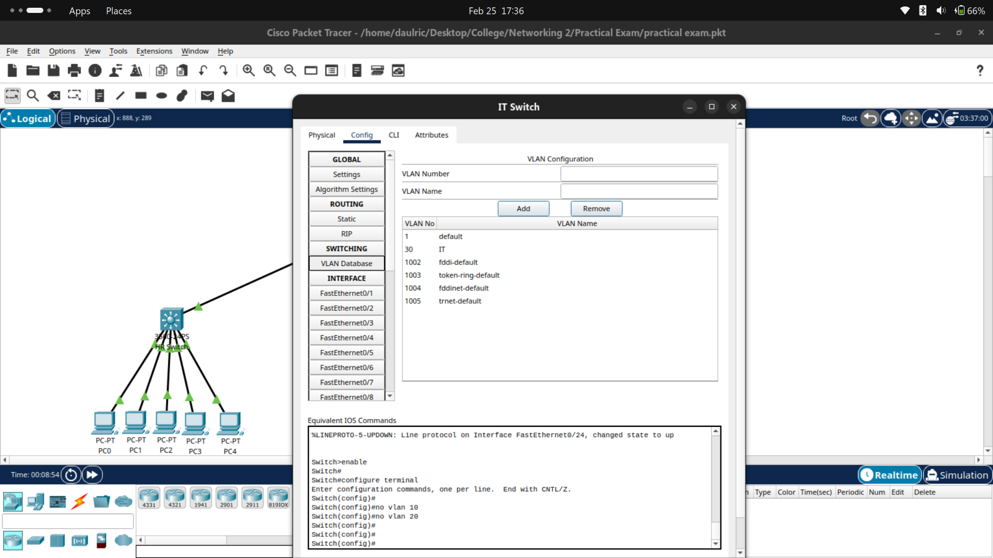

Ping test were accurate and worked seemlessly.

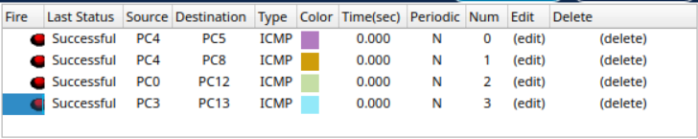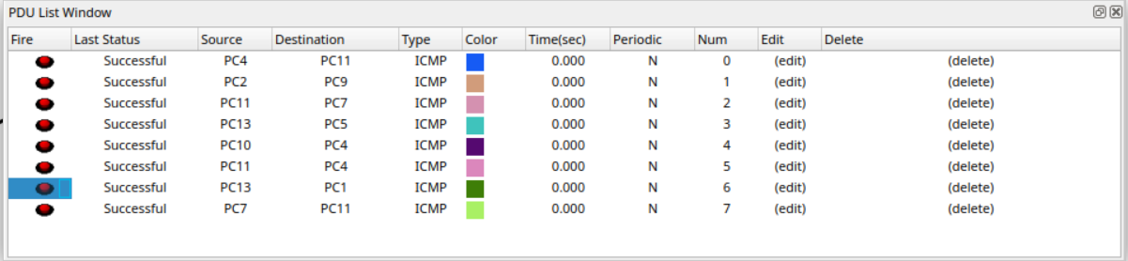

Router Configuration

